HR ANALYTICS
Employee Workforce Report
311 employees, 2006 to 2019
Prepared by Idowu Blessing Apara

Project Overview
The dataset contains 311 employees and 39 columns of HR records covering 2006 to 2019.
- Employee details: names, IDs, dates of birth, hire and termination dates, department, manager, and position.
- Pay and performance: salary, performance score, engagement survey, satisfaction score, and absences.
- Sourcing and demographics: recruitment source, marital status, and related fields.
- No hires, terminations, or performance reviews exist after 2019.
The raw file had quality issues, so the work ran in three steps: clean the data, build an interactive dashboard, then answer eight business questions with a clear action for each. The headline result is a turnover rate of 33.4 percent, and it is not spread evenly. It concentrates in the Production department, in employees under 30, and in the years 2015 and 2016.

Data Cleaning Process
- Recalculated Age and Tenure to a fixed 31 December 2019 cutoff instead of today’s date.
- Filled 8 blank Manager IDs using a name lookup (all reported to Webster Butler, ID 39).
- Standardised text with TRIM and PROPER on five columns, keeping acronyms like IT and DBA intact.
- Reconciled EmploymentStatus with the Termd flag and cleared TermReason for active staff.
- Added Term_Year, Age_Group and Exceeds, then converted every formula to a static value.

Dashboard Overview and KPIs
Eight KPIs summarize the workforce at a glance.
Total Employees | 311
Active | 207
Terminated | 104
Turnover Rate | 33.4%
Average Age | 38.5 yrs
Average Tenure | 4.84 yrs
Average Salary | $69,021
Average Engagement | 4.11

Q1. Turnover rate and turnover by department
Answer. Overall turnover is 33.4 percent, 104 of 311 employees. Production is highest at 39.7 percent. Sales is lowest among staffed teams at 16.1 percent.
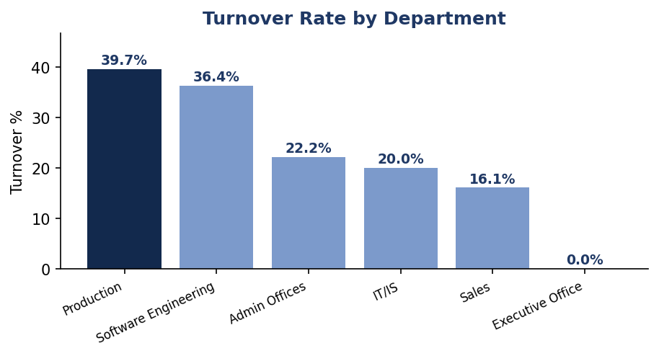
Insight. Production has both the most people and the highest exit rate, so it drives most of the company’s departures. Software Engineering is next at 36.4 percent.
Recommendation. Start retention work in Production. Run stay-interviews, review supervisor quality, and check workload and shift design.

Q2. Year with the most terminations, 2010 to 2018
Answer. 2015 had the most terminations at 23, with 2016 close behind at 22.
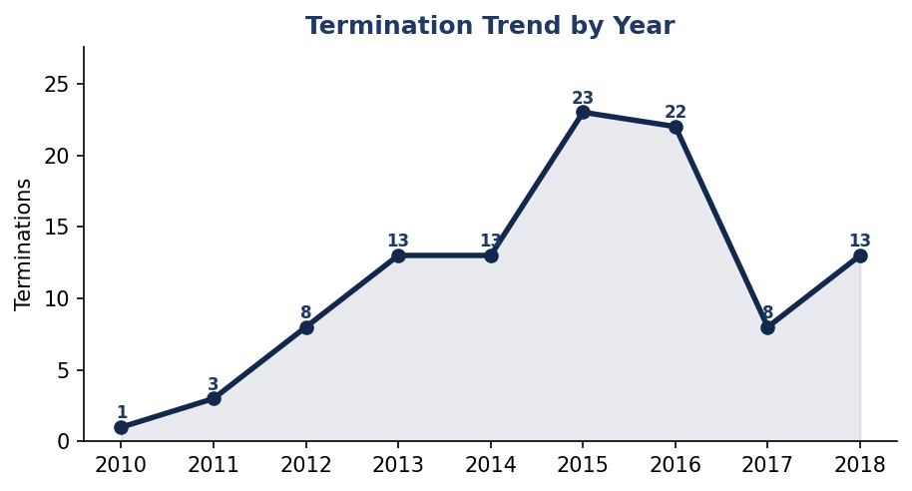
Insight. Exits climbed from 2012 and spiked across 2015 and 2016. A jump like that usually points to a specific cause, not steady churn.
Recommendation. Review what changed in 2015, such as leadership, pay, or a large earlier hiring group. Log an exit reason for every leaver going forward.

Q3. Average tenure of leavers, Production vs IT
Answer. Leavers stay about 3 years on average. IT/IS staff leave at 1.3 years, while Production leavers stay 3.3 years. Production does not leave sooner.
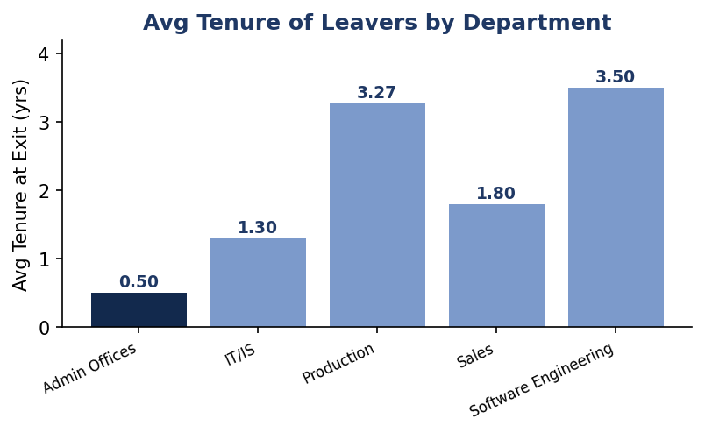
Insight. IT/IS loses people fast, which points to fit and onboarding. Production loses people in volume, but only after a fair run.
Recommendation. Improve the first year in IT/IS with proper onboarding and a 90-day checkpoint. Keep the Production focus on volume, not speed.

Q4. Best recruitment source
Answer. Indeed brings the most hires at 87. The Diversity Job Fair brings the best quality, with about 1 in 5 hires rated Exceeds.
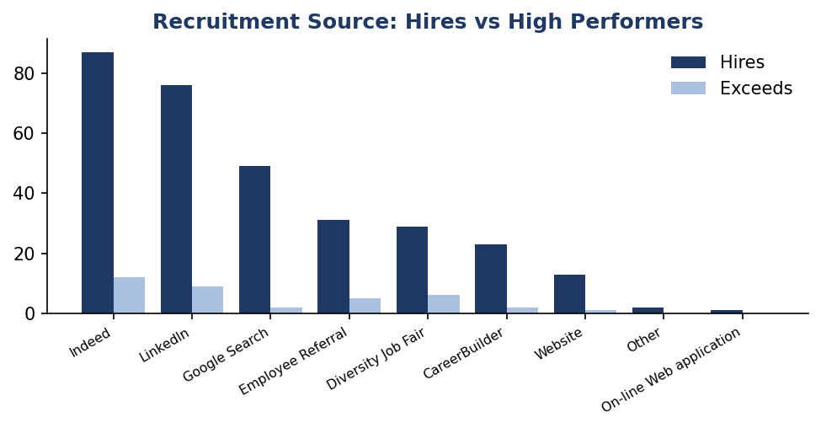
Insight. Volume and quality come from different channels. Ranking sources by headcount alone hides the ones producing the strongest hires.
Recommendation. Keep Indeed and LinkedIn for reach. Grow referrals and the Diversity Job Fair for quality, and track performance per hire by source.

Q5. Gender pay gap
Answer. Men average $70,629 and women average $67,787. The gap is $2,842, or 4.2 percent.
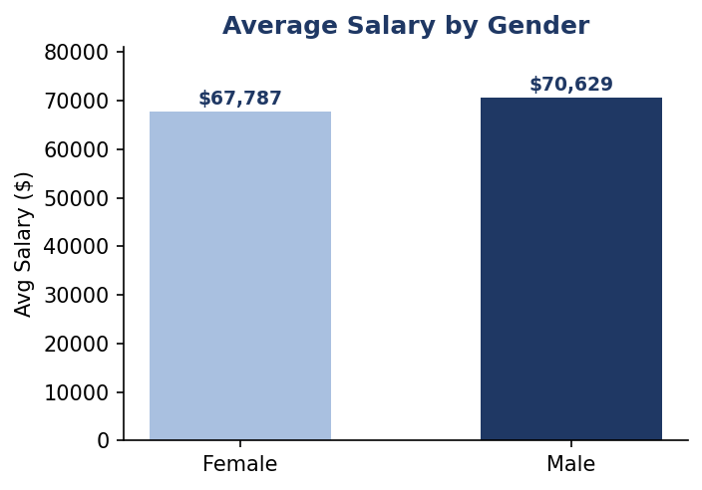
Insight. The gap is small, and a raw average hides role, seniority, and tenure. It could shrink or grow once you compare like for like.
Recommendation. Run a pay review that holds position, tenure, and performance constant, then track the adjusted number each year.

Q6. Age group with the highest turnover
Answer. Under 30 has the highest turnover at 77.5 percent, more than double any other age group.
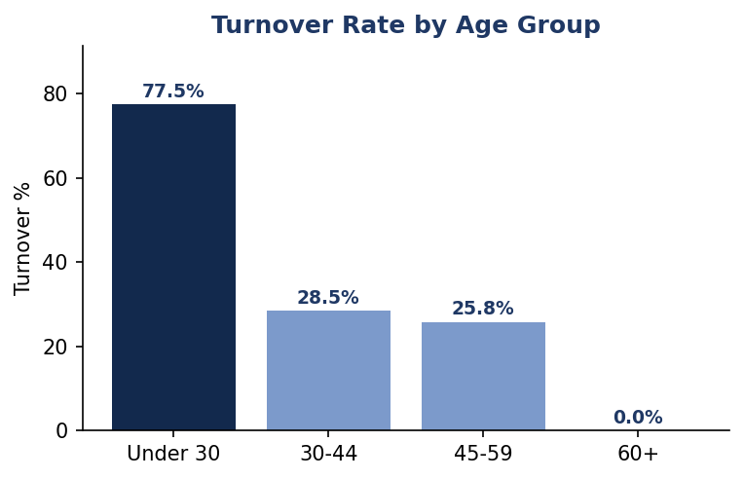
Insight. Early-career churn is the sharpest signal in the data. It is costly, and it hits the Production and IT/IS teams hardest because they skew young.
Recommendation. Build an early-career track: a mentor from week one, a clear 12-month path, and check-ins at 30, 90, and 180 days.

Q7. Engagement and satisfaction by department
Answer. Admin Offices has the highest engagement at 4.39. Software Engineering has the highest satisfaction at 4.09. Sales is lowest on engagement at 3.82.
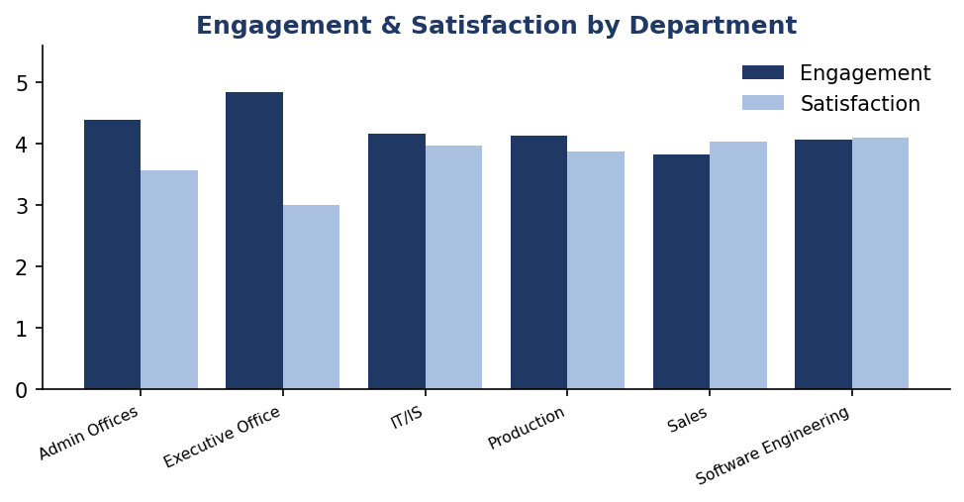
Insight. Engagement and satisfaction do not always move together. Sales is the team to watch, since weak engagement often shows up in exits a year later.
Recommendation. Run an engagement check in Sales now, and copy what Admin and Software Engineering do well.

Q8. Do high performers stay longer
Answer. Yes. Employees rated Exceeds stay 5.7 years. Those on a PIP stay 4.4 years.
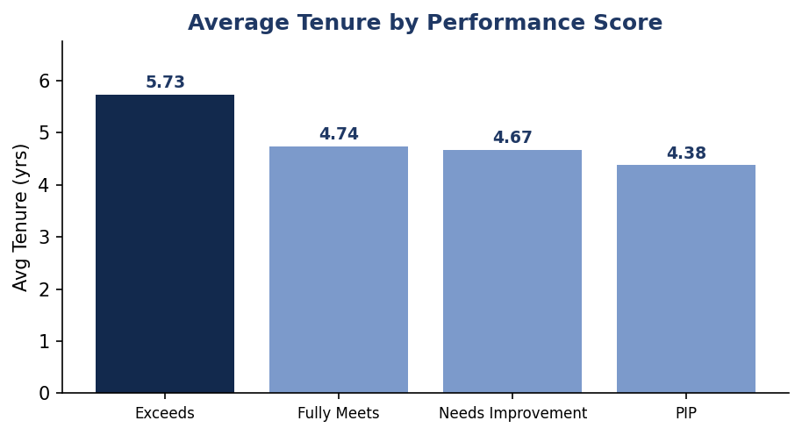
Insight. Performance and loyalty go together, so losing a top performer costs the most. A PIP is often the last step before someone leaves.
Recommendation. Protect top performers with recognition, pay, and growth. Treat a PIP as a real turnaround with support, not a formality.

Key Recommendations
- Fix Production first. It has the highest turnover in the largest team, so it moves the company number most.
- Catch under-30s early with onboarding, mentoring, and regular check-ins.
- Repair IT/IS early exits by improving the first-year experience.
- Recruit for quality by growing referrals and the Diversity Job Fair.

Conclusion
Turnover is high at 33.4 percent, but it is concentrated and therefore fixable. Three moves carry most of the value: stabilize Production, keep young employees longer, and protect top performers.

